Analysis of Samsung Group
Name
Institution of Affiliation

Abstract
Samsung Group has been one of the top performers in the tech- business world. In its inception, it was a small scale enterprise that barely dealt with any tech products. However, as it shifted towards electronics production, the implementation of appropriate management information systems enabled it to run its operations smoothly and effectively manage its resources. It has successfully implemented the customer relationship management information system, which has enabled it to provide high-level customer experience and retain its client-base. Besides, it has installed appropriate information security protocols to protect its data and clients from hackers and malicious use.
Overview of Samsung Group
Samsung Group started as a grocery trading store by exporting noodles and other goods produced in the city to China and its provinces. It was founded by Lee Byung-Chull on March 1, 1938, in Taegu in Korea. The business later started trading in textiles. After the end of the Korean War, the founder focused on industrialization to help his country revamp its effects. During this period, the firm enjoyed policies that were put by the Korean government aimed at shielding the local businesses from competition and providing easy financing at the same time. With time the company had expanded to the extent that it could cover the full production line from processing raw materials to producing a complete product. This gave the company a competitive advantage against its competitors. The firm quickly expanded into establishing new subsidiaries such as Samsung Shipbuilding, Samsung Heavy Industries, and Samsung Precision Company (Samsung Techwin). The firm also ventured into the chemical industry.
In 1969, Samsung ventured into the production of electronics, making black and white televisions. They also began making and exporting home appliances and products overseas. Several subsidiary companies, including Samsung Mechanics Company, Samsung Electronics Devices Company, and Samsung Corning Company, were formed (Michell, 2017). With the rapid growth experienced by the firm, the first aerospace division was created in 1978. In 1985, Samsung developed Samsung data systems (now known as SDS) to give growing businesses information technology services. There was also an establishment of electronics and semiconductors branches. As a way of stamping their authority in the industry, Samsung set up research and development institutes aimed at raising the bar in the company’s knowledge in electronics, high-polymer chemicals, semiconductors, telecommunications, aerospace, and such tech-related operations. Samsung had quickly become a leader in system development. In 2000, the company plugged into smartphone manufacture, which was later followed by tablet computers in 2010.
Implementation of the Management Information System
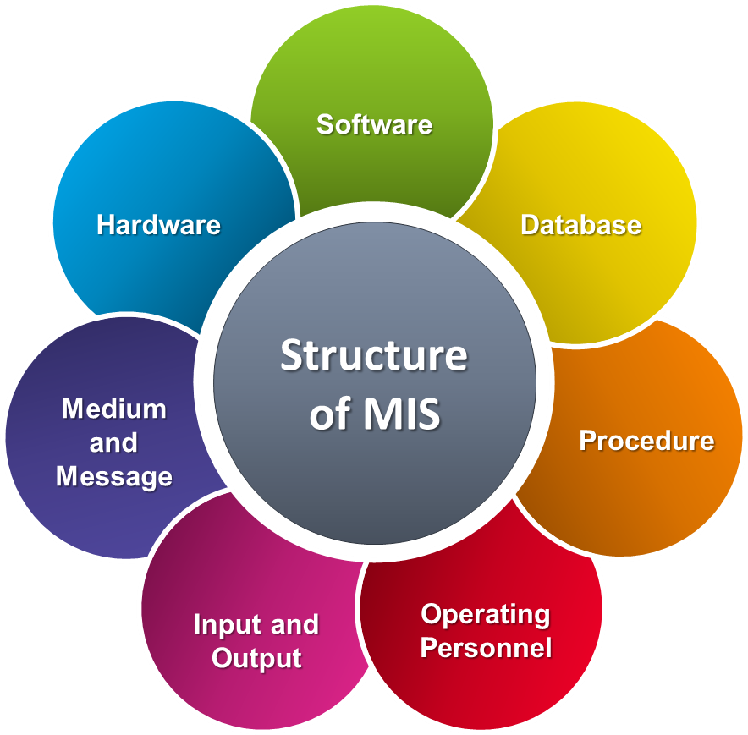
Management Information System (MIS) involves using information technology, people, and processes to record and store data for an organization’s managerial activities (Goyal, 2016). It helps to provide accurate and timely information crucial in the planning, decision-making, control, coordination, and operational functions necessary for the effective running of an organization.
Figure 1: Organizational Management Information System Model

Samsung has created a business niche in telecommunications, semiconductors, home appliances, and liquid crystal display (LCD) digital appliances. It has become a market leader in more than 60 markets, including television, mobile phones, and semiconductors. The firm has invested many of its resources in its research and development department, and innovation is one of its core strategies, as was announced in its Vision 2020 plan.
After establishing itself as a small consumer electronics company for the global market in the 1970s and 80s, the firm was quickly facing stiff competition from emerging rivals, and the demand for information technology-related services and products was increasing globally. It needed to develop a system that would quickly respond to the rapidly changing Information Technology-markets. The firm had to discard the old system and replace it with a new one to serve the rapidly growing conglomerate effectively. The global corporation runs regional divisions managed by regional managers. One of the challenges experienced by the decentralized supply control was unreliability in the demand forecast. Additionally, there was a lack of strategic planning for the firm’s inventory, and there was no standardization of information.
One of the firm’s significant innovations was the implementation of supply chain management (SCM). This would help the firm to have a centralized supply control of its globally-spread divisions. The adoption of supply chain management allowed the firm to react fast to market changes, make market-driven decisions derived from strategic demand forecasts, and standardized the information. With the centralization and the use of information systems, the firm could make more accurate production plans. This, in turn, improved customer experience because the firm could make real-time deliveries of products that are of high quality.
Furthermore, the introduction of supply chain management has led to a shortened process management cycle (Ackerman, 2017). With the utilization of real-time market information, the firm can adjust quickly to its project plans. This has resulted in simultaneous planning and execution actions in a single integrated system. It has also eliminated inefficiencies that were brought about by inaccurate demand forecasts.
Another management information system implemented by Samsung is Enterprise Resource Planning (ERP). This is a consolidated process of gathering and organizing data so that the business functions of production, accounting, and order management are automated (Hossain et al., 2015). This means that the day-to-day business processes are integrated by software. Their rapidly increasing number of transactions could not be handled by their previous system in Samsung’s case. By adopting Enterprise Resource Management, the firm could integrate all its information, covering all the processes within one system. This system connects information from all parts, including data warehouse, distribution, accounting, point of sale, and even credit card with one integrated interface.
Additionally, the various departments can use information from a single source. Enterprise Resource Planning has strong master management. This master management includes a system that shows relationships between the warehouses and partners where the flow of products can be easily monitored. The management can also monitor different aspects of the business categorized into a company, country, region, category, and even branch. This enhances the management efficiency of the firm. Again, ERP allows easy registration of products and product coded into the system.
Furthermore, the new technology allows for a promotion feature that automatically offers simple discounts and multi-unit discounts. Before introducing this technology, the human resource administrators were tasked with re-keying and synchronizing personnel information scattered across all departments. The new technology has eliminated this manual labor, and its place has allowed employees to get information regarding their pay and benefits information online. They can also enroll in training programs and run reports independent of the intervention by human resource managers. This has been a significant boost in job satisfaction.
Samsung also implemented a strategy known as knowledge management. Initially, this was started by a small group of employees to pass knowledge from one employee to another. This came to be known as “excellent integrated knowledge,” which had excellent results. A year later, these voluntary mentorship activities were linked to 6 sigmas, and the outcomes were satisfactory. With time these self-management activities were combined with scientific management techniques to produce knowledge management. What started as “information exchange meetings” or “job practice meeting” resulted in the next phase of nurturing leaders in the Communication on Progress (Cop) program. After the launch at a voluntary level, all the employees in all departments were later encouraged to join and participate. Eventually, the firm redefined its organizational culture by integrating its work, innovation, and learning. It created the company’s core knowledge, created infrastructure, and used the learning and innovation to make institutionalized activities. The soon-to-retire employees were tasked with the duty of passing their knowledge and experiences to new employees. Knowledge management has enabled Samsung to integrate its work, innovation, and knowledge into a synergy making the company a market leader. Besides, it has created a platform where employees can exchange their learning, knowledge, and experiences. This has created motivation and has made them competitive in the global scene.
SWOT Analysis for Samsung Group
Swot is an acronym that stands for Strengths, Weaknesses, Opportunities, and Threats facing any business enterprise. A SWOT matrix is a strategic planning technique a firm or even an individual can use to understand their strengths, weaknesses, opportunities, and threats. This technique helps a business assess its current position before launching new strategies (Borucka, 2018). The firm seeks to understand what is working well for them and what is not, aiming to take advantage of the former while laying strategies to reduce the latter. While strengths and weaknesses are internal to the company and have control over, opportunities and threats are beyond the company, and the firm may not have complete control.
Strengths  - What is the firm good at?  - What are the firm’s unique resources?  - What do others see as the firm’s strength? | Weaknesses  - What can the form improve?  - Which areas have inadequate resources?  - What are others likely to name as the firm’s weaknesses?
Opportunities  - What prospects are open to the firm?  - What current trends can the firm take advantage of?  - How can the firm turn its strengths into its opportunities? | Threats  - What are existing threats likely to harm the business?  - What is the firm’s competition doing?  - What threats do the firm’s weaknesses expose it to?

Table 1.1: SWOT Analysis Matrix
Strengths are aspects of the business that the firm does exceptionally well, making them stand out compared to its competitors. On the other hand, weaknesses are things that a firm could improve on that are inherently negative to the organization (Calicchio, 2020). Business opportunities are prospects or chances that could bring positive results to the business if well utilized. At the same time, threats are the aspects that would affect the business negatively if no action is taken.
One of Samsung’s strengths is its investment in research and development. Large amounts of resources are dedicated to innovative research. This has resulted in the firm producing a wide range of product portfolio that is high in quality. Product innovation and design capabilities have seen Samsung produce high-tech, well-designed ecologically-friendly products. For several years now, Samsung has produced eco-innovations that are environmentally friendly. This has earned the company’s reputation and increased its sales. Another strength identified with Samsung is that it is an award-winning brand. The firm has strategically placed itself with significant innovations backed by credibility. For many years the firm has been awarded the CES (Consumer Electronics Show) based on its products and designs.
On the other hand, Samsung’s weaknesses include over-reliance on American Markets. Although the firm has expanded its operations and diversified its resources to many parts of the world, the US market accounts for about 70% of the total sales. The overdependence can turn the tides of the firm in instances of recession. To mitigate this, the firm needs to engage European and Asian markets to create stability actively. Another of Samsung’s weaknesses is dependence on the Android OS (operating system). This poses a challenge to the business because the operating system functions and other related licenses are restricted due to Google’s Android licensing. Since the two companies are competitors, this weakens the firm’s competitiveness. Dependence on low-end smartphones has also impacted negatively on the firm’s recent declines in sales on this segment. As a result, there was a sharp decline in smartphone sales from 71 million to 55 million in the first quarter of the year 2020.
Furthermore, Samsung has previously produced faulty products and released them into the market. This has dramatically eroded the confidence and trust in its products. There has also been a leadership challenge at Samsung since its inception. This has been as a result of the firm being family-run for three generations. This may subject the firm to risk of stagnation and lack of fresh ideas.
One of the opportunities that Samsung could consider to exploit is a partnership with strategic software developers. This would provide additional functionality, thus making the company’s products more competitive. The firm should consider also consider diversification and acquisition (Surhone, 2017). This will reduce the risk of being dependant on one market that is vulnerable to the economic recession. Samsung should venture into the European and Asian economies to expand its market and customer base. With its existing infrastructure and technological advancement, Samsung can consider business growth by introducing innovative products. The electronic industry is very dynamic, and the trends go out of style very fast. Samsung can develop products that set the trend in the market. Additionally, the world moves to 5G (fifth generation of the broadband cellular network) technology, and the firm can exploit this opportunity. The firm is already in active discussions with operators for the supply of 5G and 6G network equipment.
One of Samsung’s threats is stiff competition from rivals, including Apple, Huawei, Xiaomi, and others. The competitors are working day and night to outperform and outmaneuver each other, which is a real threat to the firm’s businesses.
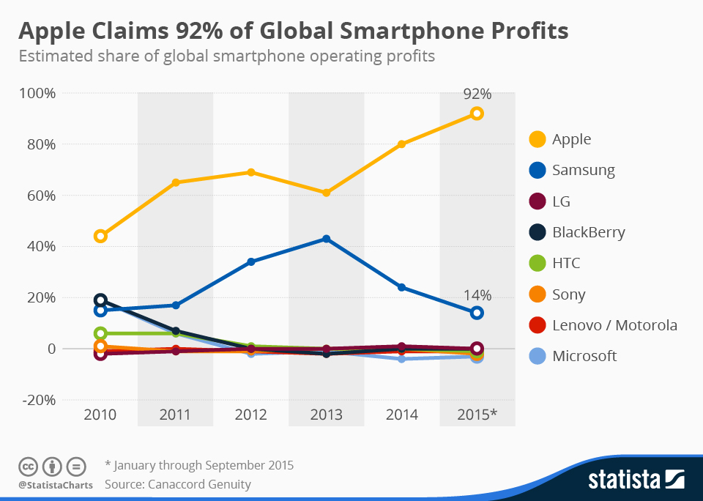
Figure 2: competition among mobile phone manufacturers
Besides genuine competitors, Samsung faces a threat from counterfeit products. The firm’s products are among the most counterfeited products. Being a global producer, Samsung faces legal and regulatory threats from various countries where the firm operates. Government regulations and restrictions continue to be a hindrance to the firm’s operations. Economic uncertainty is another threat facing the Samsung group. Recession and a decline in demand for Samsung products are a significant threat to the firm.
Customer Relationship Management at Samsung Group
Customer relationship management involves strategies, practices, and technologies that an organization puts in place to manage and analyze its customers to improve customer experiences and customer retention. Customer relationship management goes beyond applying technology in serving customers, understanding customer needs and behaviors to create healthy and lasting relationships. It is more of a business philosophy combined with a technological solution meant to serve the customers more efficiently and effectively (Shanthi, 2019). Customer relationship management involves seeking to know customers’ purchasing habits, opinions, and preferences, profiling some individuals and groups targeted for effective marketing, and improving customer service. The overall goal of customer relationship management is to increase sales.
One of the strategies Samsung has put into place as far as customer relationship management is concerned is satisfying customers’ wants by focussing on quality. The firm has invested many of its resources in innovations aimed at producing environmental-friendly quality products. High-quality products ensure that customer needs are adequately met. This results in customer retention and brand loyalty. Besides, the firm strives to build long-term relationships through customer experiences. The firm’s stores allow customers to experience the products even if they were not to buy them. The employees at these stores ensure that every customer has a great and memorable experience at these stores. They also advise the customers how the products work and how they will enrich their lives. The customers are encouraged to touch and experience these products first-hand. Besides selling the current products, Samsung employees interact with customers to understand their needs and, most importantly, forecast future needs and how their products could solve future problems.
Another customer relationship management strategy has been the development of different products targeting different customer segments. Samsung has also used the pricing strategy because most of its products are moderately priced. Furthermore, it has a wide range of distribution sites ranging from Samsung shops, mobile centers, online websites, retail stores, franchises, agencies, and electronic shopping centers. This creates convenience for customers and ensures that their products are always within reach. Samsung’s communication strategy has also been significant. It has run and continues to run promotions and campaigns to create awareness of their products, product features, and use them better. The firm has also invested many of its resources in creating advertising’s visuals to attract more customers. Another technique that has been put into practice is the automation of customer support. With the introduction of Chatbots, the firm can respond to customer concerns in real-time. This improves their engagement with their customers while at the same time, creating healthy relationships.
Information security at Samsung Group
Information security refers to the process of preventing unauthorized access, destruction, or modification of organizational information. It is the process of keeping company data secure from malicious use. Company information can experience various insecurities from introducing Malware meant to damage organizational devices and data, information hacking, phishing, and leaking of confidential information. One of the ways organizations can adopt to guarantee information security is to have sufficient information access control. To prevent unauthorized access to information, organizations should adopt the use of password-protected rooms that are limited to a few people (AL-Zahawi, 2019). The use of a digital signature could also be established. This technique identifies the person accessing the information, and it also validates digital files. A firm could additionally establish a regulation that restricts the use of personal equipment at the firm premises. This reduces the leaking of information from the company.
Samsung Group has invested in an excellent back-up system such that information is stored in at least two copies stored in different places. This ensures that the firm can quickly retrieve information lost through fires, accidents, or maliciously destroyed. For an information security guarantee, Samsung’s research has built an intelligent security platform to ensure that customer information is kept secure. It has also developed core security technologies to ensure complete security. The firm has also developed an intelligent security platform that collects, refines, analyses, and predicts the organization’s vulnerabilities and possible security threats. Additionally, the firm has invested in biometric authentication technology that allows the users to access the information using ultrasonic fingerprint and face recognition. This ensures that only the authorized personnel get access to the most private company information.

References
Ackerman, K. B. (2017). Fundamentals of supply chain management: An essential guide for 21st-century managers. DC Velocity Books.
AL-Zahawi, O. S. (2019). Information security handbook for ISO 27001 controls. UR academy.
Borucka, B. (2018). SWOT & SO WHAT? Make sense of your plans. Get to know how to build your business plan, undertake proper marketing decisions, and be more successful than others. Meet the SWOT analysis rediscovery. Exertus Group LTD.
Calicchio, S. (2020). Swot analysis in 4 steps: How to use the SWOT matrix to make a difference in career and business. Stefano Calicchio.
Goyal, D. (2016). Management information systems: Managerial perspectives (4th ed.). Vikas Publishing House.
Hossain, L., Patrick, J., & Rashid, M. (2015). Enterprise resource planning: global opportunities and challenges: Global opportunities and challenges. IGI Global.
Michell, A. (2017). Samsung Electronics and the struggle for leadership of the electronics industry. John Wiley & Sons.
Shanthi, R. (2019). Customer relationship management. MJP Publisher.
Surhone, L. M., Timpledon, M. T., & Marseken, S. F. (2017). SWOT analysis. Beta script Publishing.

